Your surroundings affect all the other data you collect! Examine & record the sample area.
LOCATION: site name, city  RIVER MILE:  Using Hudson River Estuary Map  LATITUDE & LONGITUDE: | _______________________________________  _______________________________________  _______________________________________
AREA:  Describe your area in 1 sentence so someone could find your sample location. | _________________________________________________  _________________________________________________  _________________________________________________
SAMPLING SITE:  Check all that apply | __Pier __Grassy  __Forested __Parking Lot  __Beach __Covered in vegetation  __Banks altered __RipRap (Large rocks)  __Wood Bulkhead __Concrete Bulkhead  __Pipe entering the water __Marshy
SURROUNDING LAND USES:  Record as a percentage of 100%  For example, 50% is half the usage | ___ Urban/residential ___Forested  ___ Industrial/commercial ___Beach  ___ Other (explain) __________
SHORELINE  Record as a percentage of 100% | ___Sandy ___ Muddy ___Rocky
RIVER BOTTOM:  Check all that apply: | Estimated Water Depth (cm)______  ___Bottom muddy ___Bottom sandy  ___Bottom weedy ___Bottom rocky
WATER: Describe the water itself | ____Calm ___Choppy
PLANTS IN THE WATER:  Record the aquatic plants (plants growing in the water) as a percentage of the total area.  IF NONE, please check None. | % ____ Plant________________________  % ____ Plant________________________  % ____ Plant________________________  % ____ Plant________________________  % ____ Plant________________________  % ____ Plant________________________  ______No Plants in the water

SKETCH YOUR SAMPLING SITE: Be sure to include a compass rose showing N/S/E/W and locate the river on your sketch, and note your sampling site.

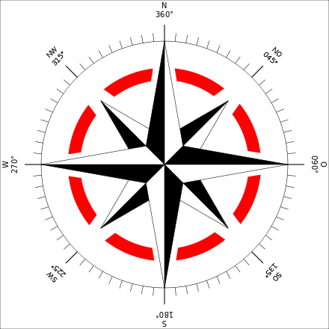
COMMERCIAL TRAFFIC: Record any large boats, tugs, or barges. Record the name, color, direction & if it is light/loaded (Loaded barge with cargo sits lower in the water.)

Time: Name Color North or Southbound Loaded or Light
_____________________________________________________________________________________
Time: Name Color North or Southbound Loaded or Light
_____________________________________________________________________________________
Time: Name Color North or Southbound Loaded or Light
_____________________________________________________________________________________

RECREATIONAL TRAFFIC: Record any sail, speed, or other rec. boats.

Time: Name Color North or Southbound Loaded or Light
_____________________________________________________________________________________
Time: Name Color North or Southbound Loaded or Light
_____________________________________________________________________________________
Time: Name Color North or Southbound Loaded or Light
_____________________________________________________________________________________

